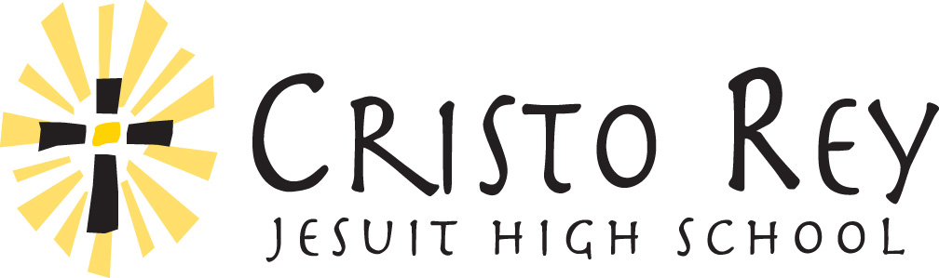

TITLE: CIP Driver
DEPARTMENT: Corporate Internship Program (CIP)

Overview of School: Cristo Rey Jesuit High School empowers Baltimore youth to succeed in college, career, and life. We provide access and opportunity for students of religious, racial, and ethnic diversity to excel through rigorous academics, a corporate internship program, extracurricular activities, and faith formation. We transform lives in the Catholic, Jesuit tradition of faith, justice, and reconciliation.

Responsibilities
Responsibilities include, but are not limited to:
- Provide transportation to students to and from internships, with the primary objective of ensuring their safety and security
- Consistently arrive on time to the school in the morning, transport students to work on time, and pick up students in a timely manner
- Communicate transportation issues and student concerns with the CIP staff in a timely manner
- Identify ways to efficiently complete driving routes
- Build strong relationships with CIP staff

Qualifications
- Must be at least 21 years old and holds a valid Maryland driver’s license
- Possesses a solid driving record with no more than two points
- Experience and/or eagerness to work with urban students and families
- Passionate about CRJHS mission and Baltimore youth
- Character and employment references required
- Ability to pass Human Resources screening requirements (criminal background check and drug screening)

Schedule
- Work during the school year from August-June, with time off during school breaks/holidays
- Work primarily during the following hours: 7:45-9:45 am and/or 3:30-5:30 pm. Morning and afternoon shifts are available. Drivers will work approximately 10-20 hours per week.
- Be flexible to work an adjusted schedule due to weather related issues or occasional student schedule changes.

Bonuses
- Yearly Driver Retention Bonus
- Bi-weekly Paycheck Bonus
- Additional driver opportunities available throughout the school year

To apply: Send your resume, along with a copy of your driving record from the MVA to hr@cristoreybalt.org. No phone calls, please.

