**HEALY Gymnasium - Patterson Park (UTZ FIELD)**

**Address: 420 S. Chester Street, Baltimore, MD 21231**

**200 S. Linwood Avenue, Baltimore, MD 21224**

**School Personnel:**

**Athletic Director:** Izrah Hurd **School Nurse:**

410-727-3255 Ext. 1031 410-727-3255 Ext.

[ihurd@cristoreybalt.org](mailto:ihurd@cristoreybalt.org) [abcde@critoreybalt.org](mailto:abcde@critoreybalt.org)

**Dean of Students:** Derrick Lifsey **Principal:** Dr. Joseph Mitala

410-727-3255 Ext. 410-727-3255 Ext.

[dlifsey@cristoreybalt.org](mailto:dlifsey@cristoreybalt.org) [jmitala@cristoreybalt.org](mailto:jmitala@cristoreybalt.org)

**MedStar Health Athletic Trainers:**

Carissa Colangelo Jenna Page

717-870-6377 410-952-9215

[Carissa.K.Colangelo@medstar.net](mailto:Carissa.K.Colangelo@medstar.net) [Jenna.M.Page@medstar.net](mailto:Jenna.M.Page@medstar.net)

Josh Barracks Kim Bosely

631-334-7533 443-506-1753

[Joshua.A.Barracks@medstar.net](mailto:Joshua.A.Barracks@medstar.net) [Kimberly.D.Bosely@medstar.net](mailto:Kimberly.D.Bosely@medstar.net)

**Teams & Locations:**

**Gymnasium -**  Fall (STEP), Winter (Basketball/Cheer), Spring (Fashion)

**Patterson Park (UTZ FIELD) -** Fall (Men’s and Women’s Varsity Soccer), Spring (Men’s Lacrosse)

**PATTERSON PARK - *HOW TO ENTER***

**Linwood Ave. Entrance:** While on Linwood Ave traveling North, walk West toward **WHITE DOME.** Field will be visible **DOWNHILL.**

**Baltimore St. Entrance(Emergency and Authorized Vehicles): While on Baltimore St. traveling East, there will be a path to enter Patterson Park. Follow the path going left and down the hill. Once at the Tennis Court, there will be a graveled path that leads to the gated entrance of UTZ FIELD.**

***AED Located on Field (Living Classrooms Pavillion - SE Corner of Field)***

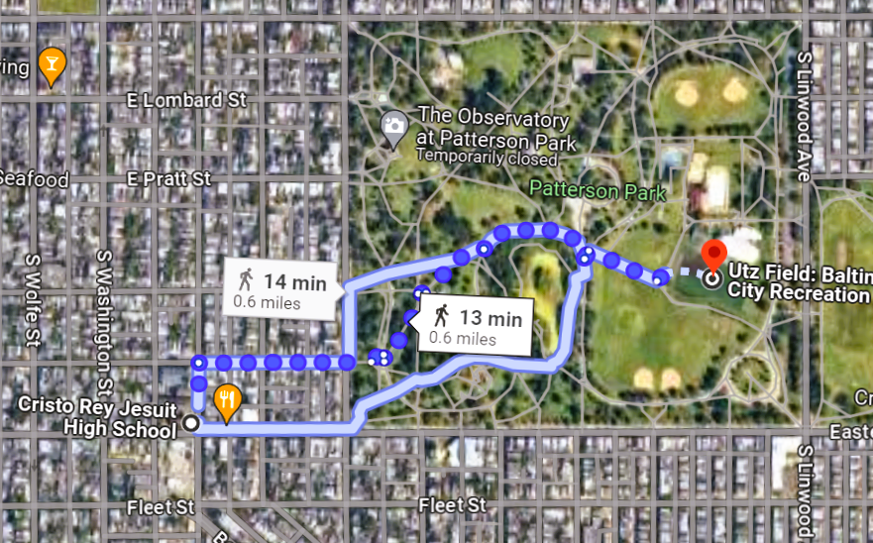

**HEALY GYMNASIUM ENTRANCE (*On-Site*): 420 S. Chester - Parking on Bank St.**

**AED Located in Main Office**

**EMERGENCY EXIT (AED #2)**

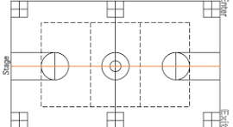 **MAIN OFFICE**

**Kitchen Area (AED)**

**EMERGENCY EXIT**

**\* *Visiting Team Locker Room will be located in Room 218 - Computer Lab*** *

**EMERGENCY PLAN (***WITH* ***Athletic Trainer*** *Present***) -**

1). **The Athletic Trainer** will initiate care for the athlete. The **Athletic Trainer** will assess the situation and activate EAP. The **Athletic Trainer** will care for the athlete and assist EMS in the preparation for transport.

2). **Athletic Director** will retrieve AED and activate EMS of the emergency by calling 911.

3). **Head Coach** will make sure the field is cleared of all student athletes to ensure their safety during this time.

4). **Assistant Coach** will direct EMS to the emergency scene.

**EMERGENCY PLAN (***WITHOUT* ***Athletic Trainer*** *Present***)** -

1). **Head Coach** will care for athlete and notify Athletic Director

2). **Assistant Coach** will activate by calling EMS and retrieving the AED.

3). **Athletic Director *or other CRJ Staff*** will oversee clearing of the field to ensure safety of other athletes. Athletic Director will also direct EMS to the emergency scene.

**Transportation -**  In the event of an EMS transport a parent/guardian or coach must accompany the athlete.

**Documentation -** All injury/illness reports will be handled by medical professionals/personnel who provide care and shared with the School Nurse and Athletic Director.

**Local Emergency Rooms**

**The Johns Hopkins Hospital UMMC Midtown Campus Medstar Harbor Hospital**

1800 New Orleans Street 827 Linden Avenue 3001 S. Hanover Street

Baltimore, MD 21287 Baltimore, MD 21201 Baltimore, MD 21225

410-955-5000 410-225-8000 410-350-3510

*In an event athlete needs **Urgent Care,** not considered an emergency transport will be:

**MedStar Health Urgent Care: Federal Hill**

1420 Key Hwy

Baltimore, MD 21230

855-910-3278

**Injuries, Policies, & Procedures:  *All coaches, athletic administrators, and athletic trainers are AED and CPR Certified. EAP Roles are assigned dependent on on-site staff.***

* ***SUDDEN CARDIAC ARREST -*** Sudden Cardiac Arrest is a medical emergency triggered by an electrical disturbance in the heart that stops it from beating and pumping blood to the rest of your body. Early recognition of signs/symptoms **PRIOR** to loss of responsiveness include:

*SYMPTOMS IN MEN* *SYMPTOMS IN WOMEN*

1. Chest Pain, angina, and/or ear, neck pain 1. Center Chest Pain (Inconsistent)
2. Severe Headache 2. Lightheadedness, Shortness of Breath
3. Excessive Breathlessness 3. Uncomfortable Pressure (Squeezing/Full)
4. Vague Malaise (general discomfort) 4. Nausea/Vomiting
5. Dizziness/Palpitations 5. Cold Sweat
6. Increasing fatigue 6. Pain Discomfort arms/back/neck/jaw
7. Indigestion/Heartburn/GI Symptoms

A lack of blood flow can present as unresponsive, unconscious, and/or no breathing. If this occurs activate EMS:

1. ***Call 911***
2. ***Get an AED and use it as soon as possible.***
3. ***Continue CPR until EMS arrives and takes over - if multiple rescuers are present cycle CPR repetitions every 2 minutes.***

* ***SEVERE ORTHOPEDIC INJURY -*** Any orthopedic injury which may cause compromise to neurovascular structures, potential loss of limb, or severe bleeding must be treated as an emergency. This may include but ***not limited to:***  fractures, tears, dislocations, avulsions, or amputations. Immediate care of these injuries may prevent long term damage or deficits.

1). *Recognition*

1. Deformity of a bone, joint, or soft tissue structures.
2. Loss of sensation, particularly in the extremities
3. Severe Bleeding
4. Open fractures or visible bone

2).Treatment

1. Provide first aid as needed. Control bleeding with direct pressure. (*Tourniquet may be considered)*
2. Treat patient for signs of shock.
3. Activate EMS
4. In case of a **CLOSED FRACTURE/DISLOCATION**, a trained medical provider may attempt to carefully position the injured body part in proper anatomical position. If there is resistance or increased loss of sensation, the body part should be left in the position it was discovered in.
5. *Splint* injured body part to prevent excessive motion.
6. Check neurovascular status (pulse, sensation, etc.) every 3-5 minutes.

* ***CONCUSSIONS -*** Athletes who experience one or more of the signs and symptoms listed below after a bump, blow, or jolt to the head or body may have a concussion.

*Observed Signs* *Reported Symptoms*

* Appears dazed or stunned 1). Headache or “pressure” in head
* Is confused about assignment or position 2). Nausea or vomiting
* Forgets instruction 3). Balance problems or dizziness
* Is insure of games, score, or opponent 4). Doubled or blurry vision
* Moves clumsily 5).Sensitivity to light
* Delayed response 6). Sensitivity to noise
* Loses consciousness (*even briefly)* 7). Feeling sluggish, hazy, or foggy
* Mood swings 8). Concentration or memory issues
* Can’t recall events prior to hit or fall 9). Confusion
* Can’t recall events after hit or fall 10). Just not “feeling right” or “slow”
* ***CERVICAL SPINE INJURY PROCEDURES -*** If athlete is unconscious following an injury to head or neck; complaining of pain down spine; inability to feel hands, feet or extremities; obvious deformity; or loss of bowel contents; or any reason you suspect a neck injury, follow these steps:

1). Assess ABCs and Severity of Injury

2). Activate EMS - use speakerphone to keep hands free for stabilization

3). Stabilize Cervical Spine - this should be the most experienced medical provider available.

4). If supine, begin the equipment removal process if warranted.

5). If prone, log roll with 4 person push or pull mechanism and then begin equipment removal if warranted.

*LACROSSE SPECIFIC PROCEDURE (STEPS 6 - 8):*

6). The athlete’s face mask should ALWAYS be removed to be able to access the airway in case of emergency.

7). Equipment removal involves 3 rescuers:

i. Rescuer 1 - Remains at the head at all times

ii. Rescuer 2 - Helmet removal (**See STEP 8)**

iii. Rescuer 3 - T - Cut jersey, cut pads as necessary (i.e strings, straps)

8). *Helmet Removal -*

1. Stabilization is given to **Rescuer 2.**
2. Stabilization Techniques:

1). From the side with placing one hand on the athlete’s occiput (back of head) and the other hand on the athlete’s chin.

2). Over top the athlete by placing hands on both sides of the head at the ear and around to the occiput.

9). Athlete is stabilized until EMS takes over.

10). Athlete must be accompanied by parent/guardian or coach when being transported.

Athletic Director Date

Athletic Trainer Date

Principal Date

Staff Member Date